Mary Magdalena Heberle Lorentz – b04101850 d18041912
Birth: | Oct. 4, 1850  Ontario, Canada
Death: | Apr. 18, 1912  Carrick  Ontario, Canada
Extracted from:
The Walkerton Telescope
April 25, 1912
Page 8
MRS. JONAS LORENTZ

MILDMAY- The death of Mrs. Mary Lorenz relict of the late Jonas Lorenz occurred suddenly at the home of her son-in-law, Jacob Schefter last Thursday afternoon. The funeral took place on Saturday morning to the Roman Catholic Cemetery.
ATTENDED FUNERAL- Mr. and Mrs. John Sutter attended the funeral of the latter's mother, Mrs. Jonas Lorentz, in Mildmay, on Saturday. The deceased was in her 61st year and died suddenly on Thursday from the effects of a paralytic stroke. She leaves a grown-up family of three sons and five daughters.
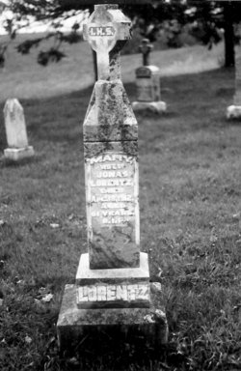
Inscription:
MARY
WIFE OF
JONAS LORENTZ
DIED
APRIL 18, 1912
AGED
61 YEARS
R.I.P.
________
LORENTZ

